Net 1061 Switching, Routing, and Wireless Essentials

Name:

Lab: #

Follow the instructions down below for the lab itself. For this lab, all answers need to be in blue font. For the questions right below, answer in complete sentences. If this is a self-grading packet tracer. Ensure you paste the screen shot of your score page at the bottom of the document. You will upload both this document and the pkt file regardless if it is self-grading or not. Let the instructor know if you have any questions.

Lab Analysis Report

1. Using complete sentences summarize work you completed during the lab.
In this lab, I verified that all the ports were in trunking mode and changed the ones that weren’t. Then, I checked to see if all the ports were assigned to the right group and corrected the ones that weren’t. Finally, I checked to see if all the groups were using LACP and corrected the ones that weren’t.

2. Using complete sentences describe what you learned from the lab. Hint; look at the lab objectives listed at the top of the lab section.
In this lab I learned more about etherchannel and how to troubleshoot it. I learned how all the ports need to be in the same mode, the same protocol, and the corresponding groups in order for the logical port to be configured.

Problems Encountered

1. Using complete sentences describe any problem(s) experienced during lab.
I didn’t experience any problems.

2. Using complete sentences describe how you solved your problem(s).

3. Using complete sentences explain if you needed any assistance with the lab; then list what you learned from that assistance.

Packet Tracer - Troubleshoot EtherChannel

Objectives
Part 1: Examine the Physical Layer and Correct Switch Port Mode Issues
Part 2: Identify and Correct Port Channel Assignment Issues
Part 3: Identify and Correct Port Channel Protocol Issues

Background
A junior technician recently configured four switches. Users are complaining that the network is running slowly, and they would like you to investigate.
Port Channel Table
Channel Group | Ports | Protocol
1 | S1: G0/1, G0/2  S2: G0/1, G0/2 | LACP active
2 | S2: G0/1, G0/2  S4: G0/1, G0/2 | LACP active
3 | S1: F0/23, F0/24  S2: F0/23, F0/24 | LACP active
4 | S3: F0/23, F0/24  S4: F0/23, F0/24 | LACP active
5 | S1: F0/21, F0/22  S4: F0/21, F0/22 | LACP active
6 | S2: F0/21, F0/22  S3: F0/21, F0/22 | LACP active
Device Table
Device | Group | Ports
S1 | 1 | G0/1, G0/2
S1 | 3 | F0/23, F0/24
S1 | 5 | F0/21, F0/22
S2 | 2 | G0/1, G0/2
S2 | 3 | F0/23, F0/24
S2 | 6 | F0/21, F0/22
S3 | 1 | G0/1, G0/2
S3 | 4 | F0/23, F0/24
S3 | 6 | F0/21, F0/22
S4 | 2 | G0/1, G0/2
S4 | 4 | F0/23, F0/24
S4 | 5 | F0/21, F0/22

Instructions

Examine the Physical Layer and Correct Switch Port Mode Issues

Look for access ports.
Examine the switches. When two or more redundant links connect the same switches, Spanning Tree protocol will only put one port in forwarding mode to prevent switching loops. You can see this in Packet Tracer. When physical ports are assigned to an EtherChannel port, they behave as one logical port. Each pair will either be operational or down.

Verify ports are in trunk mode.
      - Verify that all physical ports in the topology are configured as trunks. Correct any ports that are in access mode.
      - Correct any EtherChannel ports that are not configured as trunks.

Identify and Correct Port Channel Assignment Issues

Examine port channel assignments.
The Packet Tracer topology and the Port Channel and Device tables provide details about the physical ports and their EtherChannel assignments. Use the show etherchannel summary command to learn how the EtherChannel links are configured. Verify that the switches are configured as shown in the documentation.

Correct port channel assignments.
Correct any switch ports that are not assigned to the correct EtherChannel port.

Identify and Correct Port Channel Protocol Issues

Identify protocol issues.
In 2000, the IEEE released 802.3ad (LACP), which is an open standard version of EtherChannel. For compatibility reasons, the network design team chose to use LACP across the network. The design team has made it a requirement that all ports that participate in EtherChannel need to actively negotiate the link as LACP. Verify that the physical ports are configured as indicated in the topology and Port Channel Table.

Correct Protocol issues.
      - Correct any switch ports that are not negotiating using LACP.
      - Reissue the show etherchannel summary command to verify that all EtherChannel links are now correctly configured.

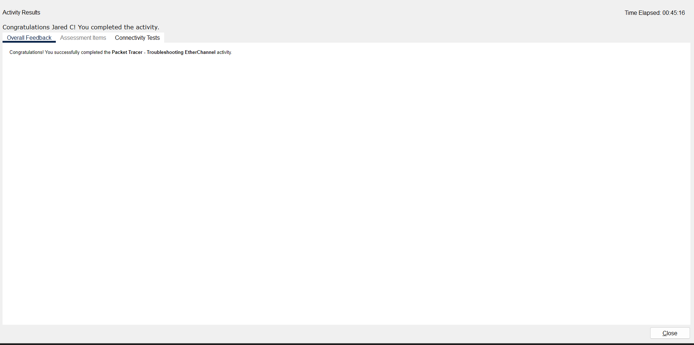
End of Document

